ODA Agricultural Water Quality Practices Solution
Creation and Publication Notes
March 4, 2026
Purpose:
Create a ‘living’ repository of suggested agricultural/environmental practices to maintain and improve the quality of water for all waters of the State. Practice links and solutions to be maintained by ODA staff.
Requirements:
- Needs to be updatable by ODA staff, or the contents needs to be updatable.
- Needs the ability to grow and adapt.
- Must be interactive with browser, no special software required.
- Should be usable on a phone.
End Goals
- Ability for landowner to identify/search for Ag Practices related to their land.
- A tool for ODA/SWCD natural resource staff to link land conditions to Ag Practices, as well as the ability to share results with landowners
- A tool for ODA compliance staff to share land conditions to applicable Ag practices, as well as the ability to share results with landowners
- A tool for public and partners to see Ag practices recommended for TMDLs
- A tool for ODA to publish and prioritize Ag Practices recommended for TMDLs: required for implementation plans, reporting, and can be used for landowner funding prioritization for grant funding
Audience
- Landowners
- SWCD Staff/conservation professionals
- ODA Staff and referral reference to others
Timeline
- Would like to have a beta version complete in 2026, available funds must be spent by 12/31/2027

Why
- ODA Water Quality Program has no organized reference to point landowners and professionals to common solutions
- Allows ODA Staff to walk through possible solutions (in-field or remotely) leaving landowners with a resource tool and/or report
- It is common for landowners to not know that there are water quality rules for agriculture to follow – this is a guide to the rules, technical assistance and potential solutions
- It is common for ODA WQ and SWCD Staff to have a biology or environmental background, but not all have an agricultural background; this tool will help shorten that knowledge gap providing a training aspect to the tool.

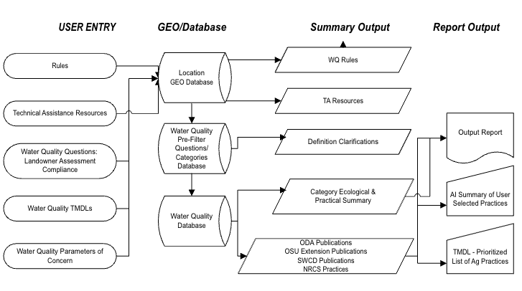
Basic Application Data and User Interface Flow

